

SCHOOL OF ENGINEERING

|  |
| --- |
| **Design Project: Mobile Application – CS4201** |
|  |

PROJECT REPORT

SCRAPCART

Enrollment Id Enrollment No.

Shambhavi Goswami AU19B1006

Bachelor of Technology (2020-2021)

**Contents**

|  |  |  |  |
| --- | --- | --- | --- |
| **S.no** | **Topic** | | **Page no.** |
| Chapter-1 | Understanding the Problem | | 1 |
|  | 1.1 | Problem Statement | 1 |
|  | 1.2 | Domain | 1 |
|  | 1.3 | Project Objective | 1 |
|  | 1.4 | Stakeholders | 2 |
|  | 1.5 | Problem Overview | 3 |
|  | 1.6 | Constraints & Challenges | 3 |
| Chapter-2 | User Requirement Analysis | | 4 |
|  | 2.1 | User Requirements | 4 |
| Chapter-3 | Ideation and conceptualization | | 5 |
|  | 3.1 | Brainstorming Ideas | 5 |
|  | 3.2 | Project Scope | 6 |
|  | 3.3 | Benchmarking | 7 |
| Chapter-4 | Design and methodology | | 8 |
|  | Wireframe Design | | 8 |
| Chapter-5 | Implementation | | 16 |
| Chapter-6 | Testing | | 30 |
| Chapter-7 | Result & Conclusion | | 40 |
| Chapter-8 | References | | 43 |

**Chapter 1**

**Understanding the Problem**

This chapter is organized as follows. Section 1.1 presents the problem statement in brief. Section 1.2 describes the selection of the domain. Section 1.3 describes the overall objective of the project. Section 1.4 describes the stakeholders who will be directly or indirectly is a part of the system. Section 1.5 describes the overview of the problem in general. Section 1.6 describes the different constraints and challenges that may arise during its development.

# Problem statement

A need for having a platform where people can have the ease of selling their scrap or junk materials and get a fair price for their items.

# Domain

# Business (Selling Scrap)

# The scrap buyers can connect to this application via the business firm who has their own community of their buyers and the user willing to sell their items can schedule their requests and a particular collector of that locality will be assigned to the user.

# Project Objective

# The Objective is to make the user experience a better way of selling their junk with a pick-up service from your doorstep without wasting a lot of time or discarding them in a haphazard way that may lead to not getting the liable amount .

# Also, in other hand not only for sellers but also for the scrap buyers it would be a great change in the group of buyers making them united as a group that would be easily manageable. Thereby, empowering the conventional scrap buyers by providing them a digital platform which would make them go with the current trend of the world of being digitally equipped, also making their job easier to accomplish.

# Stakeholders

# For the above mentioned application the following will be the stakeholders:

# The developer or the firm initializing the project

# They are the key stakeholders who are responsible for any changes in respect to the updating of app and settling up of privacy policies and maintaining the database of the sellers and the buyers.

# Scrap buyers

# They are part of the group who will be going to collect the items as doorstep pickup service.

# Users of the app

# People who are willing to sell their scrap to the buyer group. This will be the core group who will evaluate the functioning of the app by providing their feedback .

# Recycling Industry

# The recyclable items that are collected will be sent to their respective recycling industries . The whole process ends at them as they will be paying the scrap buyers the liable price of them items as per the weight, but they won’t be going to be a part of functioning of the application. They will be assumed as a separate factor affecting the whole process chain.

# 

# Problem Overview

# As we tend to move forward towards better technologies, this for sure produces E-scrap, and other items like metal frames, newspapers, cardboards and plastic bottles that need to be discarded. Rather than discarding them as waste, we can sell them to the scrap buyers in the locality. But for most people, it seems to be a restless job where due to the following constraints:

# Locating the buyers seems to be difficult as they don’t have a permanent location, or even if they have, carrying all of the items up to their location requires a lot of energy and time.

# For the job workers, extracting time from your frenetic schedule seems to be difficult as you probably have to wait for the buyers to come, collect the scrap, calculate the total weight with their manual weight machine and then make an estimation of the cost.

# Not only in homes but places like garages and basement lot of scrap items are kept which are needed to be removed but can’t be done due to their excessive amount of weight.

# Also, if we can properly discard the recyclable items then it will be beneficial for the environment too.

# Constraints and Challenges

# The buyer group is assumed to be a group of some minimal number of scrap buyers that are assigned to a particular location considering a small set of cities only.

# Tracking up of the scrap buyer will not be possible.

**Chapter 2**

**User Requirement Analysis**

This chapter is organized as follows. Section 2.1 presents the problem faced by the user and what they would expect while using the application

# User Requirements

# The following are the user needs that the application must provide for making the user experience of the app better:

# Fair price ratings of the scrap items.

# Category for choosing out the items provided with photos to distinguish type of papers or any other item.

# Getting an approximate money estimation of the total items on the list based on the weight.

# The contact details with their name must be provided to the seller for easy communication.

# Easy understandable language

# Must include Payment gateway

# Direct access of the location

# Tracking the route of the scrap buyer

# Cancellation of selling request must be built.

# Landmark option must be available.

# OTP verification system needs to be properly functional.

# Must display the user if the app doesn’t consider their location in range. Prior to filling up of the details while scheduling a selling request.

**Chapter 3**

**Ideation and Conceptualization**

This chapter is organized as follows. Section 3.1 presents the process of generating and brainstorming the ideas that result into the next section 3.2 expressing the project features that will be deployed in the application. Section 3.3 represents the existing application (Benchmarking).

# Brainstorming Ideas

# 

# Project Scope

# Concerning the whole journey throughout the application, these are some of the features which are needed to be deployed:

* Registration Form

# Filling up of details like First Name, Last name, Address with the landmark, Mobile number and email address.

* Login Process

# Log in to the application with your details provided while registering yourself as the user.

* Check out the scrap rate list with categories and rate provided having the following items:

# Recycle Plastics

# Paper

# Metals

# E-Waste

# About us page

# User Journey Guide

* Schedule your Junk items for selling

# Select a pick-up date

# Select a pick-up timing

# Add images of the scrap materials while adding up items on the list followed by approximate weight category.

# Add pick-up location(default set as home address)

# A message block(for more instructions or other needs)

* Allotment of scrap collector

# Scrap collector name and number displayed on the screen after successfully scheduling your request.

* View history record of the user-sold items.

# Category and Visual Benchmarking

# The Kabadiwala

* The Kabadiwala is online doorstep pickup service which helps to sell your scrap.
* We can sell Newspapers, Books, Carton, Plastic, Iron, Steel, Copper, Brass, Tin and many more recyclable materials by booking a pickup online. Our pickup vehicle will come to your place and weighs your scrap material by the electronic weighing scale and pays you a fair amount.
* The Kabadiwala is now available in only Bhopal, Indore, Raipur, Lucknow, and Nagpur.
* We can also check how much we have contributed to the Environment, refer our friend and earn money, & check the current rate of the scrap materials in our city.

# Proposed Solution

A mobile application would help schedule the selling of the junk materials that would be the safest, easiest and the most reliable way.

**Chapter 4**

**Design and Methodology**

**COLOR PALETTE**

* **Primary**

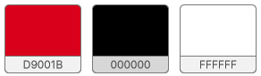

* **Secondary**

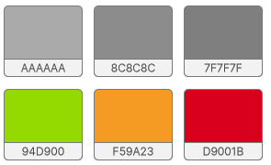

**TYPEFACE**

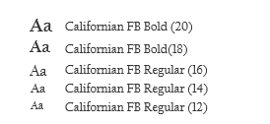

**ICONS**



**High Fidelity Wireframe**

The wireframe design starts with a display of a flash screen containing the application logo and a loading spinner and with a loading time of 5 sec and then it jumps to the Sign-In page.

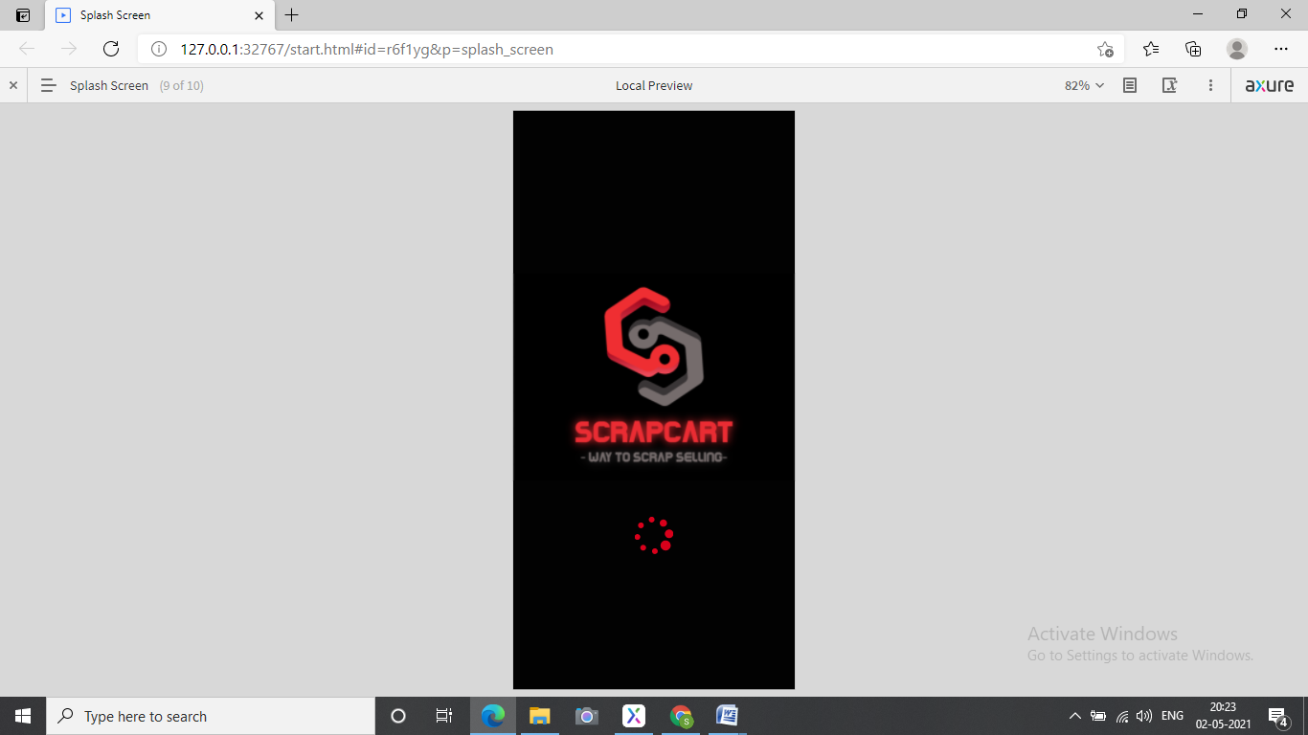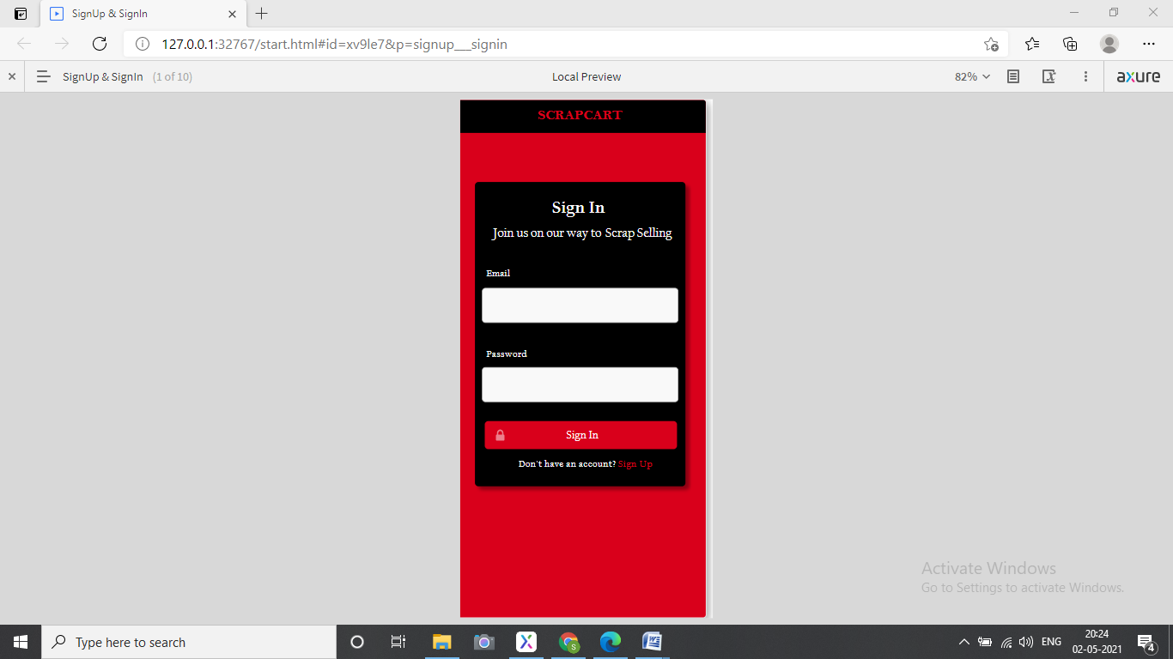

For joining as a user of the application, it requires you to sign up in by clicking the Sign-Up button. Once you click, it takes you to the Sign Up page where you are required to fill up the details abiding the constraints made for each field.

**Constraints:**

1. All the fields including Name, Email-Id, Password should be filled , otherwise an error message will be shown focusing the specific field stating it should not be left empty.
2. Name field should only contain alphabets.(No numeric or special characters)
3. Email address must have Recipient name ,‘@’ and a valid domain and top domain name.
4. The recipient name can have alphabets and numeric values .
5. Password must have at least 8 characters followed by a special character and some numeric values.
6. While filling the confirm password field, the same password given above should be inputted.
7. If an error message is displayed the text field label should be marked read followed by the error message below the text field.

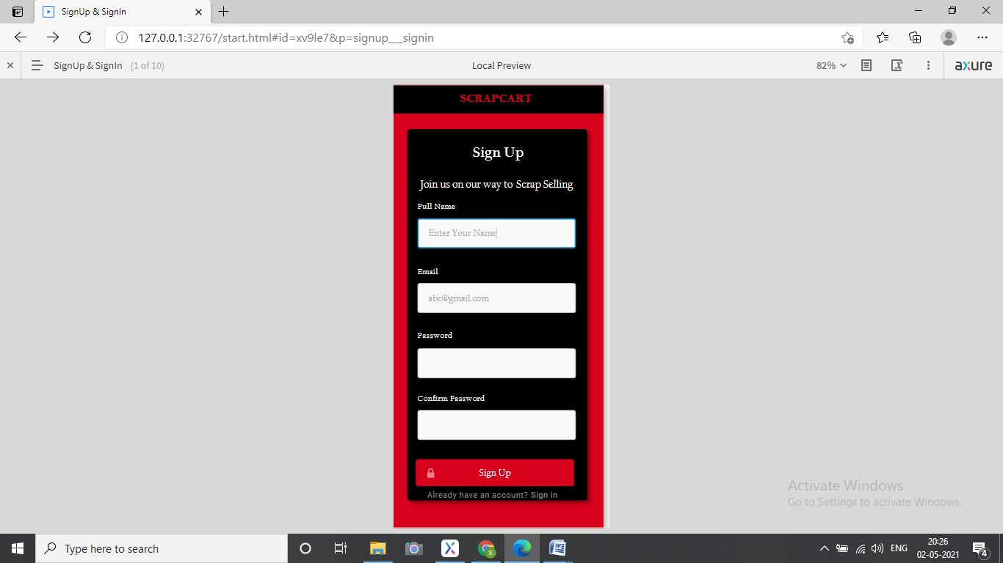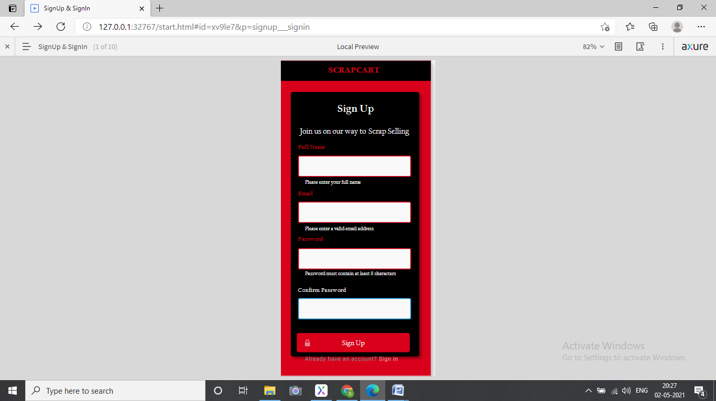

After inputting all the details , need to click up on sign Up button.

**Constraints:**

1. The contact number must be all numeric values.
2. It should not exceed more than 10 digits.

Now you have been registered as a user in the database. Now fill up the same entries you provided during the Sign up process for successful login.

**Constraint:**

The email id and password must match with the entries during Sign Up, or else an error message will be displayed stating ‘Does not match’.

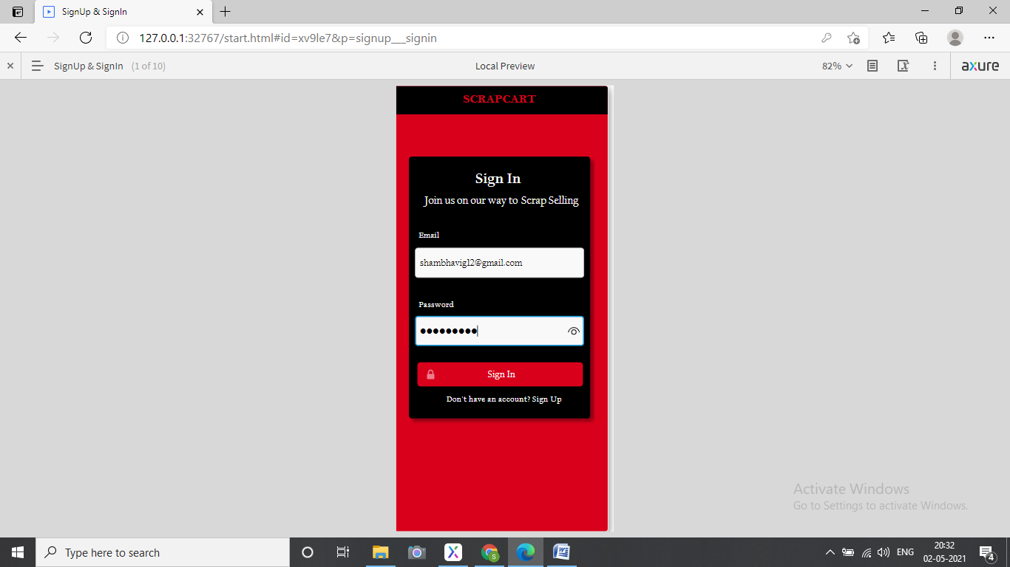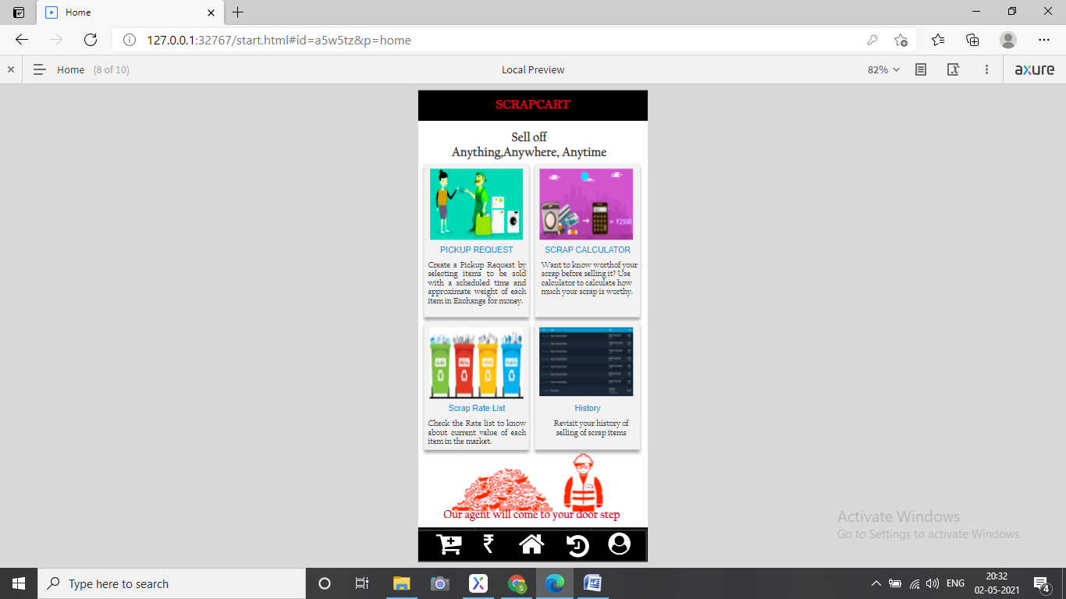

Now you will be displayed the home screen of the application displaying its different features with their information. The lower bar consists of five different tasks that can be performed in the application.

1. Pickup Request Scheduling
2. Scrap selling product list with their rates.
3. Home button
4. History for viewing your previous requests.
5. Profile button

**Pick-Up Request Scheduling**

This page will help you to schedule a request for your scrap items.

There are many fields that are needed to be inputted for successfully submitting the request .

**Constraints:**

1. All the fields are mandatory, except description field and image.
2. Date scheduling should be done using the calendar option provided .By clicking on the icon, you will be displayed a calendar in which you need to pick up a date.
3. Time should be adjusted using the arrows.
4. All the item names with their approximate weight should be inputted.(you can add as many number of items you need to sell).
5. Total scrap weight should also be provided using a slider.
6. No weight field should be given a value of less than 1 kg.
7. If needed, you can submit an image of all the scrap items.

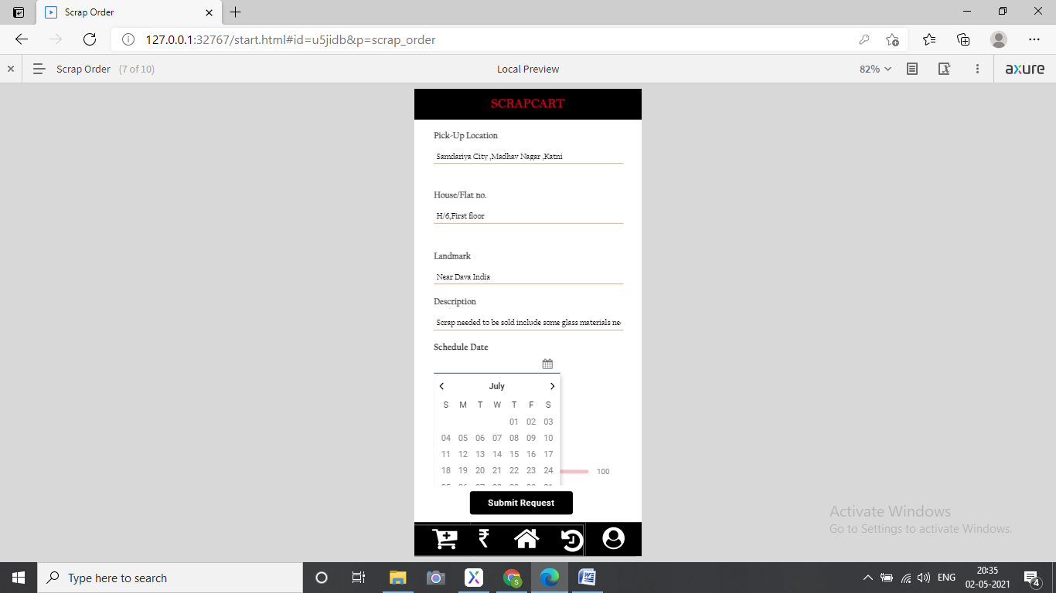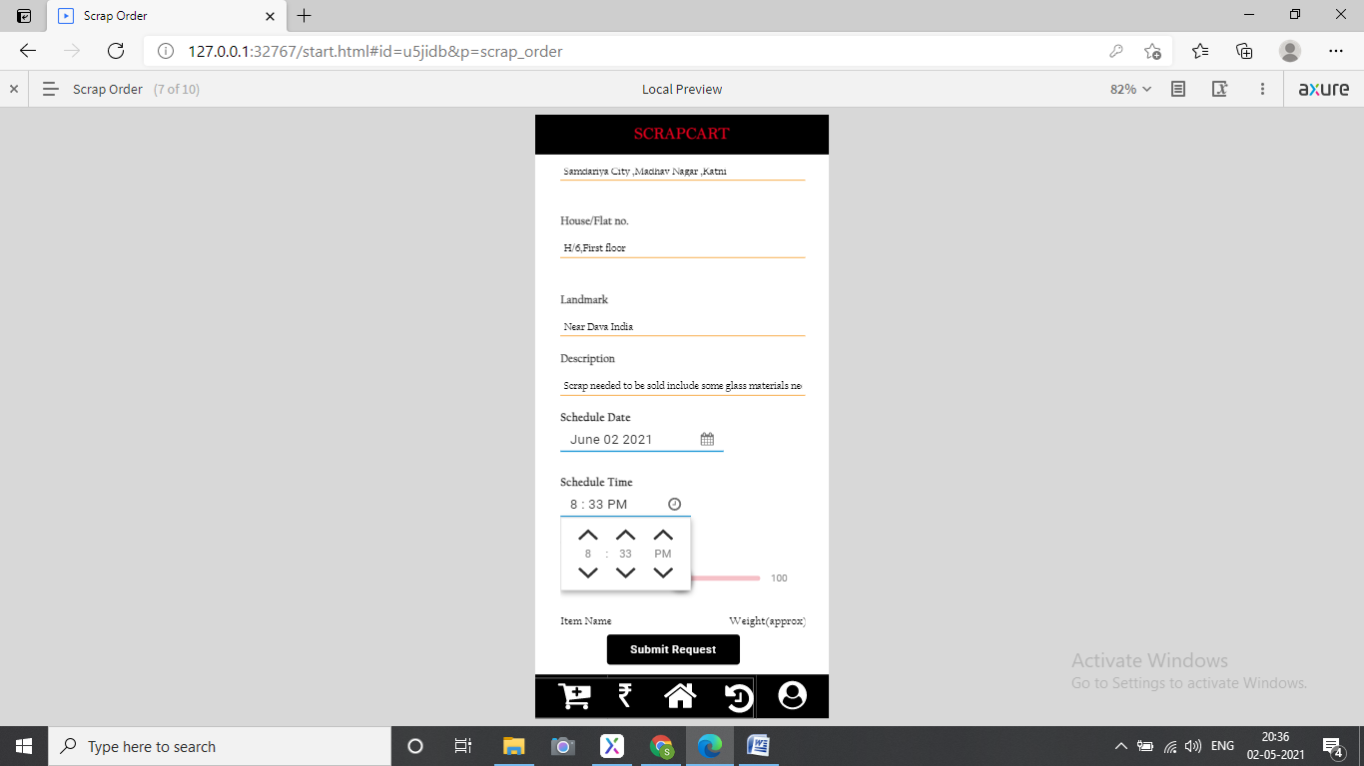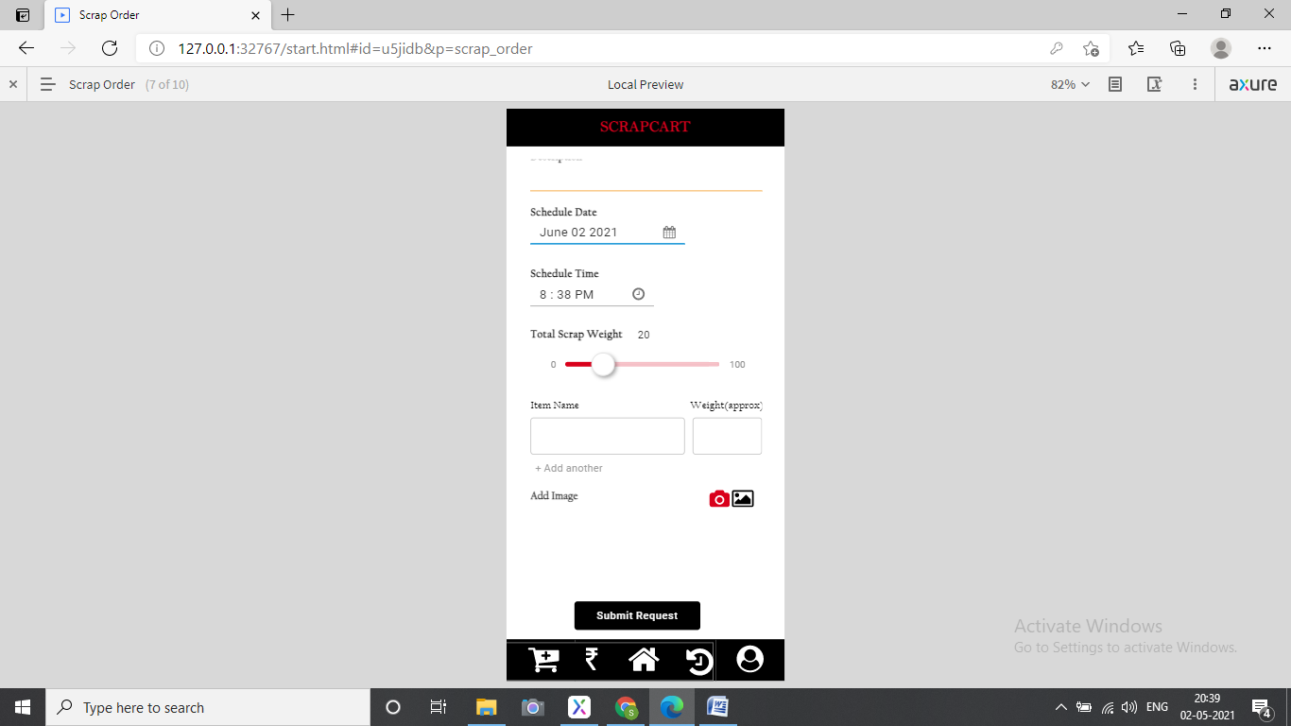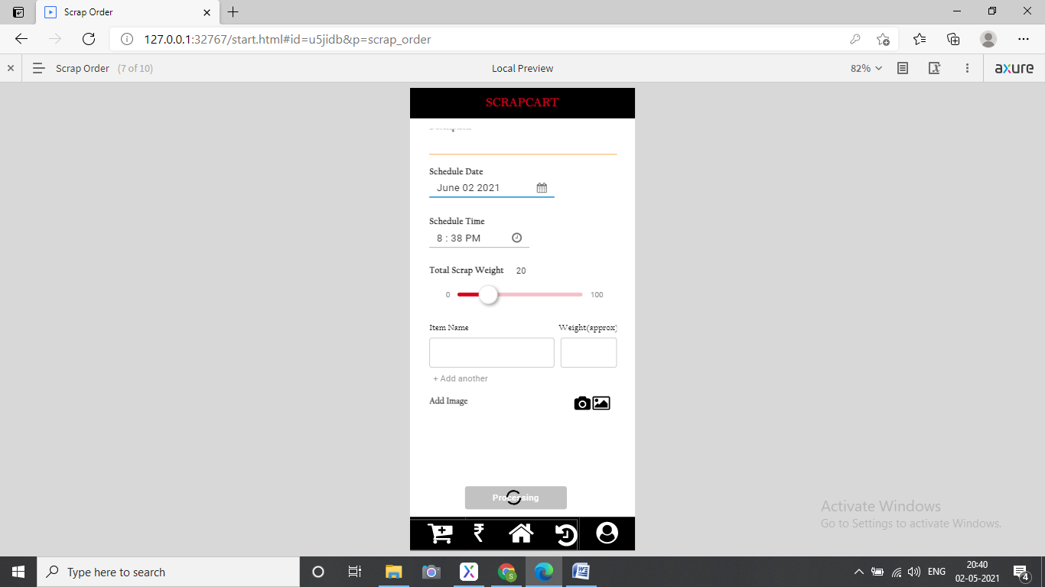

Once you click on submit request a spinner with processing button will be shown. And once it finishes the job, it will display done and the next screen displays the name, contact number of the scrap buyer you are allotted to.

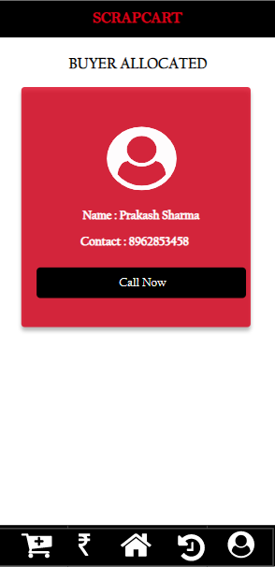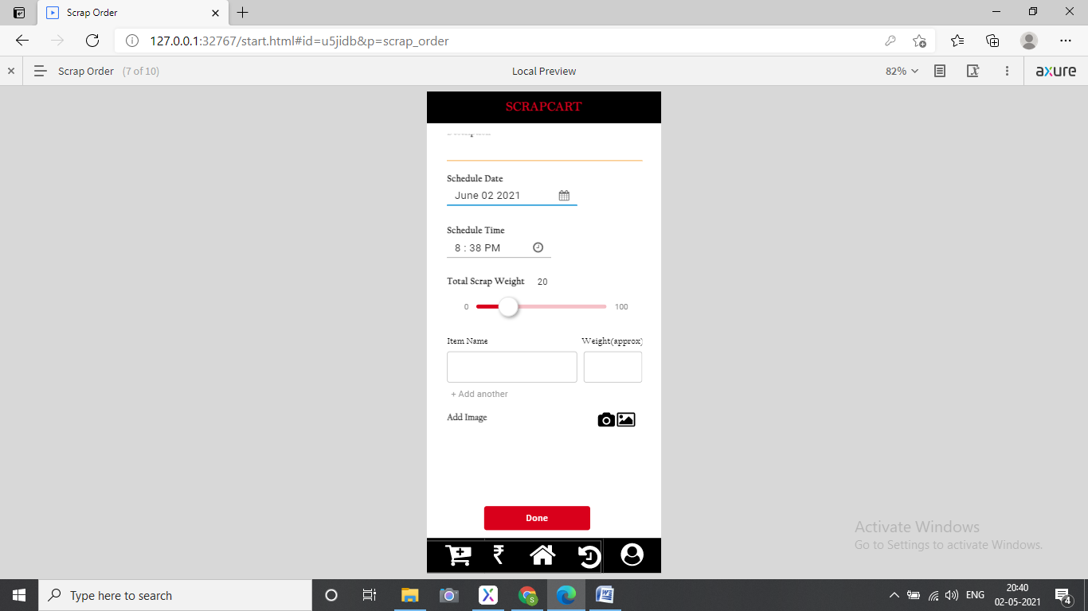

**Product and pricing**

Scrap Products that you can sell using this application with their rates are displayed.

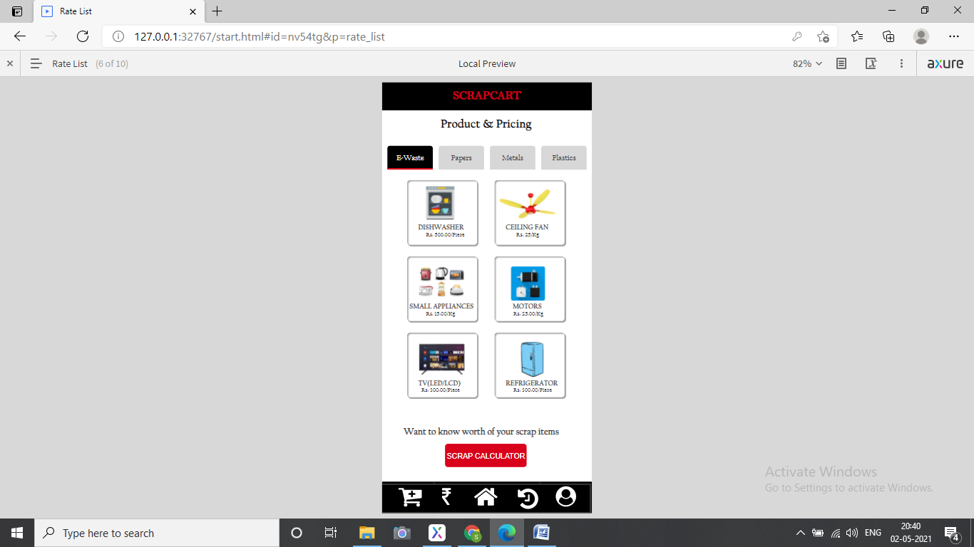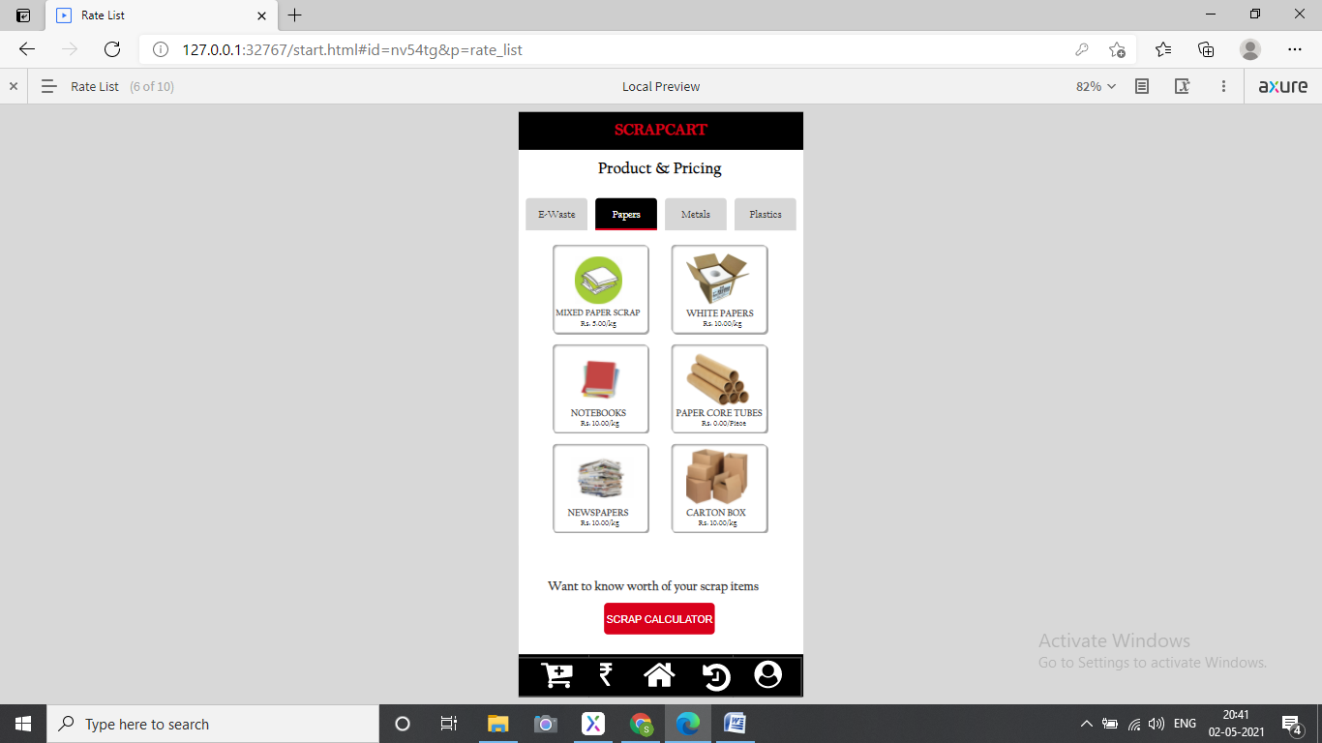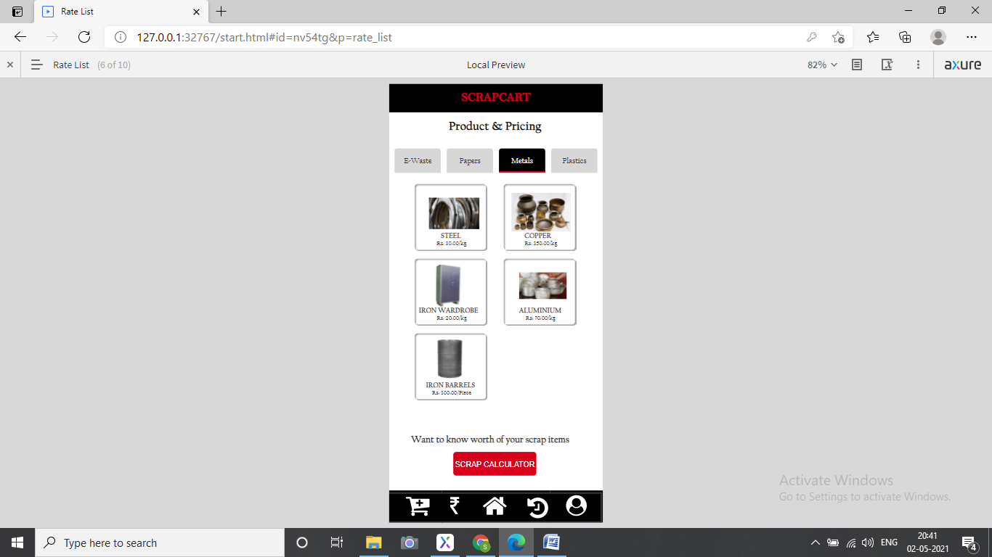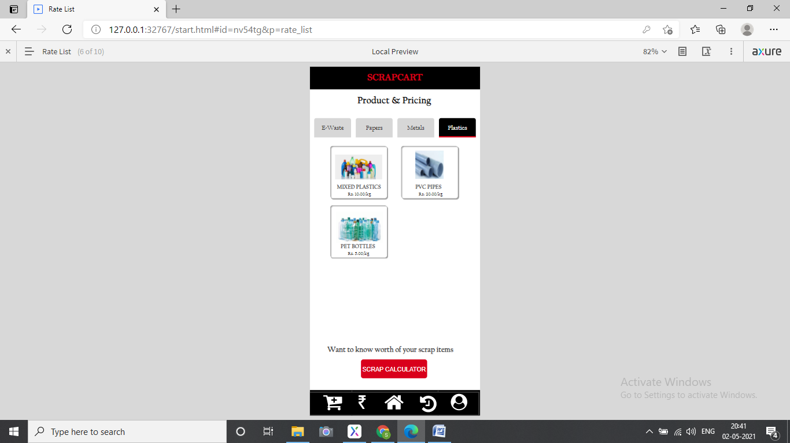

**History**

You can revisit your all scrap items you have sold till date under this tab.

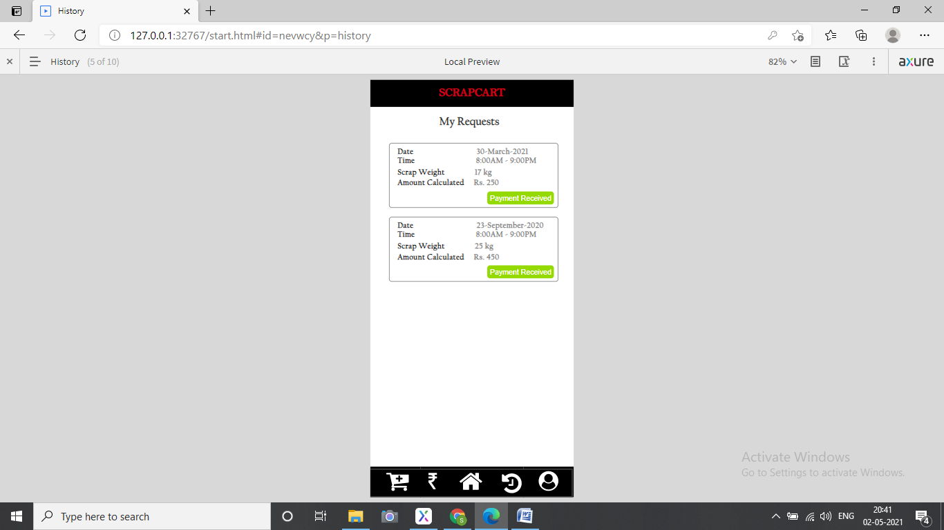

**Chapter 5**

**Implementation**

# Splash Screen Activity

The Scrap Cart application initiates with the splash screen activity, this class is invoke on creation of the app and set it display with the activity_splash.xml file, where View class is set for the display of all the widgets in which a linear layout is placed containing a GIF image view for getting customized progress loader and an image view whose target source is set to the Scrapcart logo image.

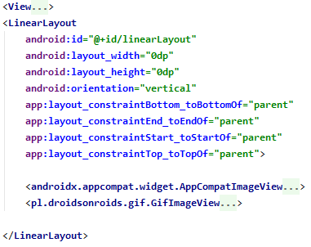

Using the runnable interface, the run() method is overridden for creating an object of Intent class binding the current activity with the login activity and closing the current activity with finish() method.

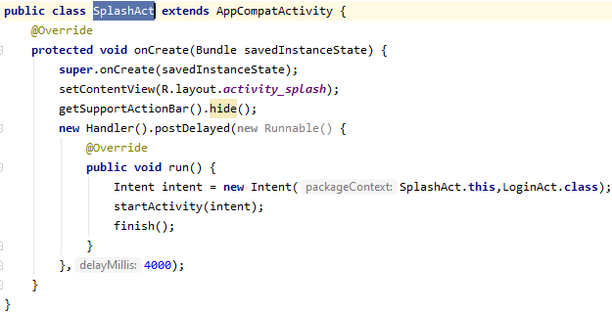

**Login Activity**

The purpose of creating a login activity is to validate the details entered by the user while creating their new account in the app with the details of the Login activity. For this in the xml files widgets like TextView , EditText and an AppCompat button for logging in is created .

In the java segment the SetOnClickListener() method is invoked on the click of the sign in and register text. If SignIn button is clicked ,it calls the loginUser() method. In the method, an object of User class is created.The user class implements constructor(), getter() and setter() methods for all the parameters such as name ,email and other parameters.

Using the setData() ,all the entries given by the user are converted to string and are stored for the later process of error validation and checking with the entries from register table in the database using the php files in order to get a successful login. If the login is successful, the user will be prompted to the next activity of the app.

Also, in the process the key value pairs are being mapped and are stored in the instance of the hash map table .It also implements the StringRequest() of Volley Library to get the string from the server url of login.php stored in the Constants class.

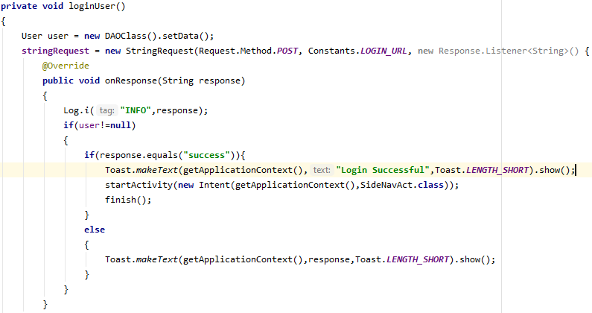

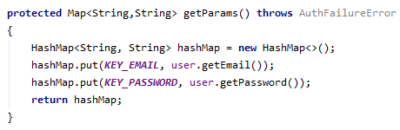

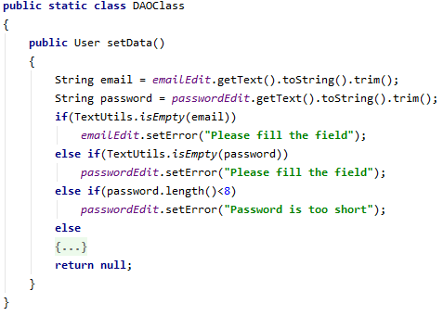

**PHP Code**

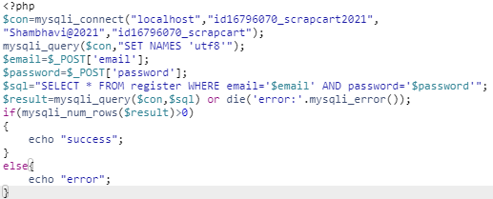

# Register Activity

# The Register activity consists of four input fields : username, email, password and contact. When the register button is being clicked upon , the registerUser() is invoked which setup data in its String variables from the EditText components. Here, the previously defined string s are being mapped to the entries of the function obtained from the User class object.

# A new request is created from StringRequest() to generate a response in posting the data obtained from the user in database using the link of ph purl php file. If the response comes to be a success, it implies that the user’s data is inserted in its respective columns of the table with a text prompting up specifying the successful registration and a startActivity operations performed prompting to the next activity for logging in.

# 

# PHP Code

# 

# Side bar Navigation Activity

# This activity provides a side navigation bar in its view using its corresponding xml files containing three menu options for navigating to the home page, Buyer list and for the case of logging out from the application using the logout menu option. A toolbar is placed in the content view whose id is being fetched in the toolbar object along with a layout corresponding to a drawer which toogle up its panel on its different sync state of opening and closing.

# A custom method of the navigation view is called upon passing the current class instance for the case when the menu item id is selected and the pointer points up to the next binding class passed as its argument of the Intent () with if and else if cases for different conditions.

# 

# XML Code

# 

# Home Activity

# The foremost menu item in the navigation field is the home activity fragment which comprises of Grid layout type components in onCreate() method with OnClickListener() for making the view component to be clickable when invoked. This methods calls for an Intent and the view is set to the next binding class in row for different Grid layout. In the Grid Layout a card view widget is set up to make the components of the Frame layout with some rounded corner and elevation from its position.

# 

# 

# Application Guide Activity

# The first layout prompts you to the functioning of the whole application in form of a guide which is implemented using the ScrollView and the linear layout component consisting of the layout images for a well understanding of the components of app.

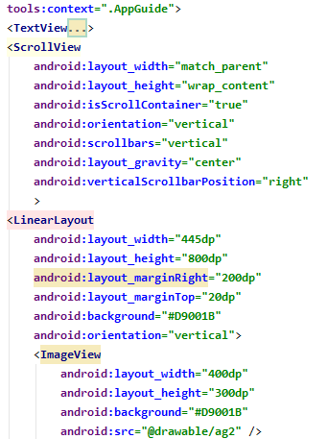

# Selling Request Activity

# This activity invokes a form to be filled up for selling you scrap items with their fields as Seller’s name, email, contact , address, landmark, city, date time , description, item name and approximate weight. The date is being fetched from the Date picker dialog and instance of the anstract class Calendar with which the attributes of date : year , month, day with a style theme dialog for date picker which is set up for the date set listener and prompts up in the text field taking the arguments of the current instance of the class, theme and date attributes from the calendar. The onDateSet() setsthe edit text view to the picked date.

# Along with this, two spinners are used respectively for selecting city and timing as per the user convenience. This is implemented using a array adapter of string type which involves the parameter of the class, spinner layout and the attribute on which the spinner is used. The isEnabled() is overridden here for checking its position and this position is passed as an argument to the getItemAtPosition() which is stored in a private string named item and is stored in the table using the StringRequest and DAOClass method. On obtaining an error, a toast is placed which will be prompted with the response obtained from the php file.

# 

# 

# 

# PHP Code

# 

# 

# Product List Activity

# This page exhibits all the Scrap Material that can be sold using this platform with their image , product name and price according to its weight attribute taken in per piece or per kg. the xml file component a ScrollView layout which can only have a single child component as the Linear layout which has its different component of image and other attributes of the product.

# Upload Scrap Image Activity

# This activity contains of three button or selecting the image, uploading the image, and fetching the image back to the image view field. On click of the select image button, its linked onClick() is being invoked using a class named Dexter which helps in managing thrun time permission which is provided in the manifest file for getting the permission of handling the external storage of the device such as gallery. If the permission is granted from user for accessing the internal storage, an intent is used for an ACTION_PICK that would return the item from data that was selected. The type of the intent is set to the image folder , to obtain the file in that specific location of the url posted.

# If the permission is denied from the user, whenever they would tap the button, they will be prompted again with the token to grant permission.

# 

# Then the compression of the image is implemented using the object of class Bitmap. The data is written into a byte array and is stored in the string encodedImage. For this an adapter is setup implementing Recycler view along with a Image Holder class.

# 

# Show Image Activity

# On clicking the show images button from the upload activity, it prompts to a new activity for fetching the image stored in the image folder. The process is followed by implementing a try – catch code in which the JSON objects are stored in the JSON array if the success value equal to the value given for the true case in php with its id and url and stored in the imageList in which a object of class ModelImage is added.

# 

# PHP Code

# 

# Buyer List Activity

# 

**PHP Code**

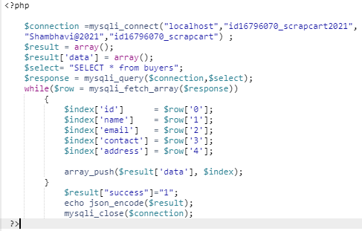

**Product Order(History) Activity**

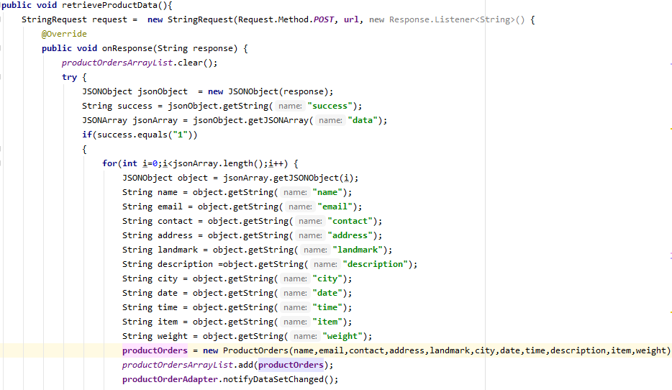

**PHP Code**

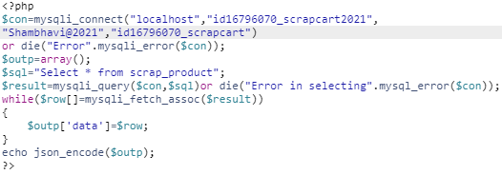

**Chapter 6**

**Testing**

**Black Box Testing**

The testing of the system is done using Black box testing approach. It is a Testing method that analyses the functionality of a application without knowing much about the internal structure/design of the item that is being tested and compares the input value with the output value. **The main focus in Black Box Testing is on the functionality of the system as a whole.**

**Functional Testing**

This type deals with the functional requirements or specifications of an application. Here, different actions or functions of the system are being tested by providing the input and comparing the actual output with the expected output.

**Test scenarios for logging in to the application**

**New user:**

If the user is new to the application, the user needs to register himself in the application database. This is being done using the Register activity which will open up on clicking the Sign up text , just below the Sign in button. Once the user has registered themselves, they can fill up the same entry details for logging in the application.

**Already have an account:**

If the user already has an account, he needs to fill the sign in details and if it gets matched, they are prompted inside the application activity.

**Error Prompt Testing**

The testing includes the following cases such as handling null values in text fields ,accepting the Submit button without any value, file upload without attachment.

|  |  |  |
| --- | --- | --- |
| **S.no** | **Functional requirements** | **Result** |
| 1 | Functional loading spinner with an active time of 5 sec | C:\Users\intel\AppData\Local\Microsoft\Windows\INetCache\IE\9ZC2ZNFT\Symbol-Correct-Mark-Ok-Choice-Right-Check-Yes-40319[1].png |
| 2 | Error message if username field kept empty | C:\Users\intel\AppData\Local\Microsoft\Windows\INetCache\IE\9ZC2ZNFT\Symbol-Correct-Mark-Ok-Choice-Right-Check-Yes-40319[1].png |
| 3 | Error message if email field kept empty | C:\Users\intel\AppData\Local\Microsoft\Windows\INetCache\IE\9ZC2ZNFT\Symbol-Correct-Mark-Ok-Choice-Right-Check-Yes-40319[1].png |
| 4 | Error message if contact field kept empty | C:\Users\intel\AppData\Local\Microsoft\Windows\INetCache\IE\9ZC2ZNFT\Symbol-Correct-Mark-Ok-Choice-Right-Check-Yes-40319[1].png |
| 5 | Error message if password field kept empty | C:\Users\intel\AppData\Local\Microsoft\Windows\INetCache\IE\9ZC2ZNFT\Symbol-Correct-Mark-Ok-Choice-Right-Check-Yes-40319[1].png |
| 6 | Name field can have alphabets only.(No numeric or special character) | C:\Users\intel\AppData\Local\Microsoft\Windows\INetCache\IE\9ZC2ZNFT\Symbol-Correct-Mark-Ok-Choice-Right-Check-Yes-40319[1].png |
| 7 | In email recipient name can have alphabets and numeric values . | C:\Users\intel\AppData\Local\Microsoft\Windows\INetCache\IE\9ZC2ZNFT\Symbol-Correct-Mark-Ok-Choice-Right-Check-Yes-40319[1].png |
| 8 | Pattern wise domain for email | C:\Users\intel\AppData\Local\Microsoft\Windows\INetCache\IE\9ZC2ZNFT\Exclamation-Mark-Symbol-PNG[1].png |
| 9 | If email already registered , checks for different email | C:\Users\intel\AppData\Local\Microsoft\Windows\INetCache\IE\9ZC2ZNFT\Symbol-Correct-Mark-Ok-Choice-Right-Check-Yes-40319[1].png |
| 9 | The contact number must be all numeric values. | C:\Users\intel\AppData\Local\Microsoft\Windows\INetCache\IE\9ZC2ZNFT\Symbol-Correct-Mark-Ok-Choice-Right-Check-Yes-40319[1].png |
| 10 | It should not exceed more than 10 digits. | C:\Users\intel\AppData\Local\Microsoft\Windows\INetCache\IE\9ZC2ZNFT\Symbol-Correct-Mark-Ok-Choice-Right-Check-Yes-40319[1].png |
| 11 | Password should be all numeric | C:\Users\intel\AppData\Local\Microsoft\Windows\INetCache\IE\9ZC2ZNFT\Symbol-Correct-Mark-Ok-Choice-Right-Check-Yes-40319[1].png |
| 12 | It should have 8 digits | C:\Users\intel\AppData\Local\Microsoft\Windows\INetCache\IE\9ZC2ZNFT\Symbol-Correct-Mark-Ok-Choice-Right-Check-Yes-40319[1].png |
| 13 | An error message is displayed the text field label should be marked read followed by the error message below the text field. | C:\Users\intel\AppData\Local\Microsoft\Windows\INetCache\IE\9ZC2ZNFT\Symbol-Correct-Mark-Ok-Choice-Right-Check-Yes-40319[1].png |
| 14 | Toast prompting “Successful Registration” | C:\Users\intel\AppData\Local\Microsoft\Windows\INetCache\IE\9ZC2ZNFT\Symbol-Correct-Mark-Ok-Choice-Right-Check-Yes-40319[1].png |
| 15 | Email must match with Sign up entry details | C:\Users\intel\AppData\Local\Microsoft\Windows\INetCache\IE\9ZC2ZNFT\Symbol-Correct-Mark-Ok-Choice-Right-Check-Yes-40319[1].png |
| 16 | Password must match with Sign up entry details | C:\Users\intel\AppData\Local\Microsoft\Windows\INetCache\IE\9ZC2ZNFT\Symbol-Correct-Mark-Ok-Choice-Right-Check-Yes-40319[1].png |
| 17 | Error message for incorrect password. | C:\Users\intel\AppData\Local\Microsoft\Windows\INetCache\IE\9ZC2ZNFT\Symbol-Correct-Mark-Ok-Choice-Right-Check-Yes-40319[1].png |
| 18 | Error for not similar inputs. | C:\Users\intel\AppData\Local\Microsoft\Windows\INetCache\IE\9ZC2ZNFT\Symbol-Correct-Mark-Ok-Choice-Right-Check-Yes-40319[1].png |
| 19 | Toast prompting “Successful Login” | C:\Users\intel\AppData\Local\Microsoft\Windows\INetCache\IE\9ZC2ZNFT\Symbol-Correct-Mark-Ok-Choice-Right-Check-Yes-40319[1].png |
| 20 | OTP Collection | C:\Users\intel\AppData\Local\Microsoft\Windows\INetCache\IE\9ZC2ZNFT\Exclamation-Mark-Symbol-PNG[1].png |

**State Transition Testing**

It is used to test the different states of the system under test. The state of the system changes depending upon the conditions or events. The events trigger states which become scenarios and a tester needs to test them.

|  |  |  |
| --- | --- | --- |
| **S.no** | **Functional Requirements** | **Result** |
| 1 | Splash screen to sign in page with a delay time of 5 sec | C:\Users\intel\AppData\Local\Microsoft\Windows\INetCache\IE\9ZC2ZNFT\Symbol-Correct-Mark-Ok-Choice-Right-Check-Yes-40319[1].png |
| 2 | Sign in to sign up page | C:\Users\intel\AppData\Local\Microsoft\Windows\INetCache\IE\9ZC2ZNFT\Symbol-Correct-Mark-Ok-Choice-Right-Check-Yes-40319[1].png |
| 3 | Sign up to sign in page | C:\Users\intel\AppData\Local\Microsoft\Windows\INetCache\IE\9ZC2ZNFT\Symbol-Correct-Mark-Ok-Choice-Right-Check-Yes-40319[1].png |
| 4 | If Sign up clicked by mistake, back parent page is login page | C:\Users\intel\AppData\Local\Microsoft\Windows\INetCache\IE\9ZC2ZNFT\Symbol-Correct-Mark-Ok-Choice-Right-Check-Yes-40319[1].png |

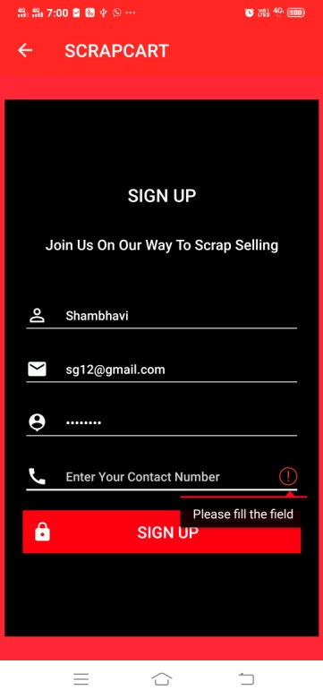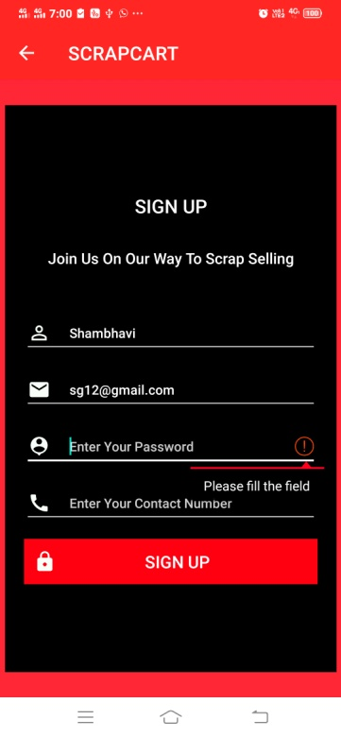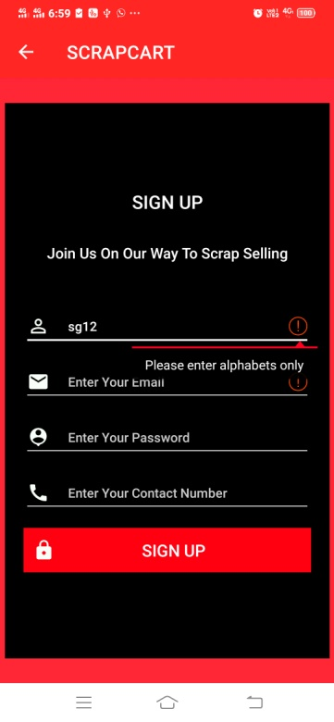

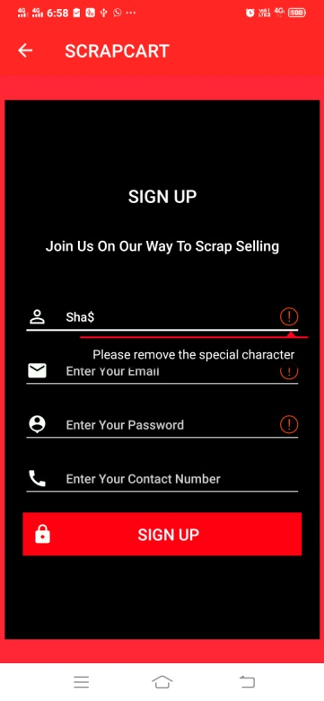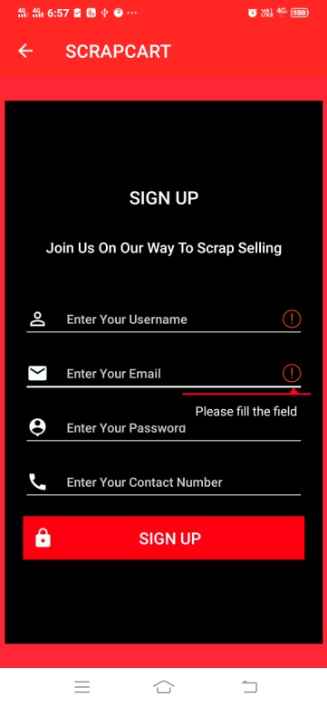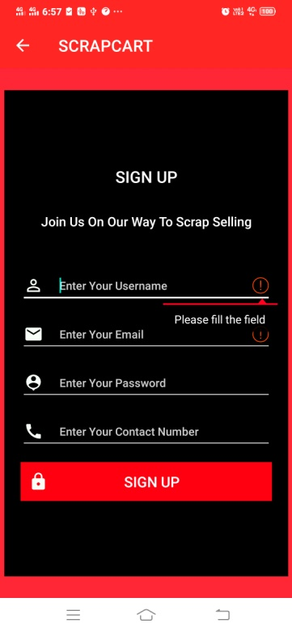

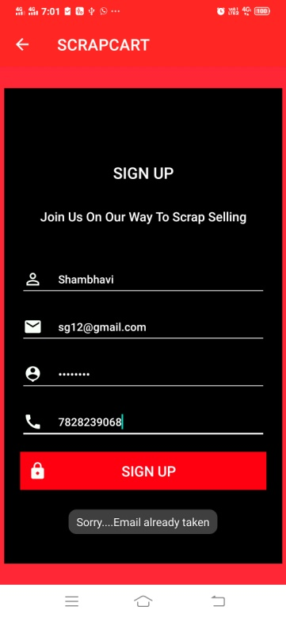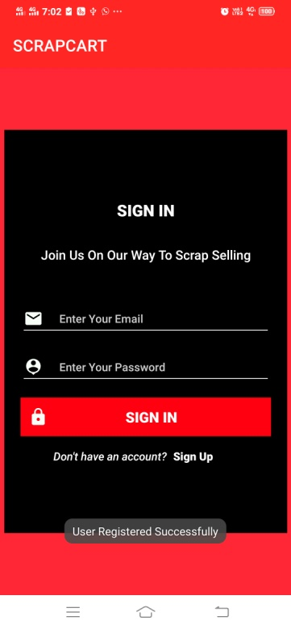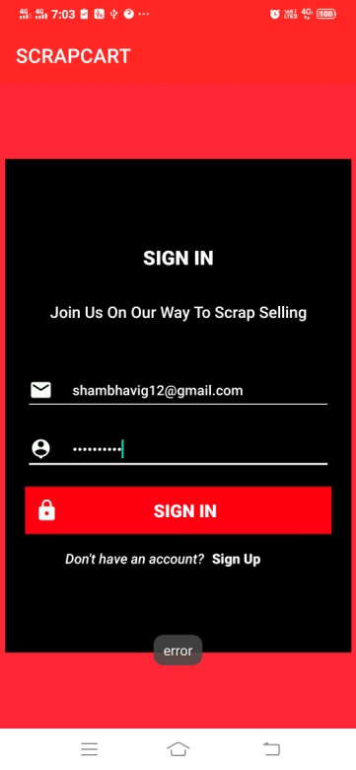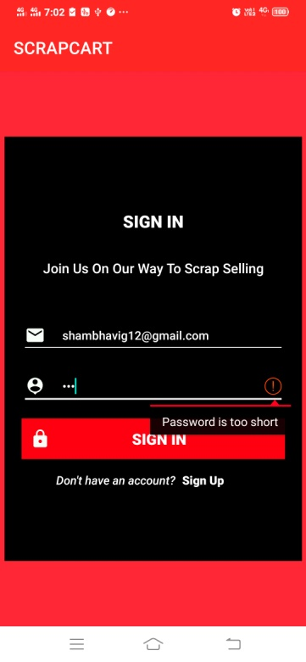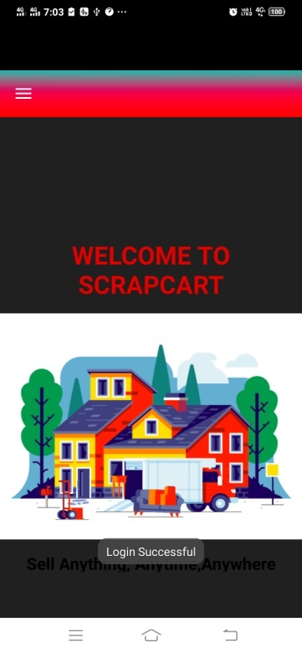

**Test scenarios for Scheduling Pick up request**

User schedules their pickup requests using this part of application which includes the implementation of following requirements.

If the user has previously uploaded some image of scrap for selling , it can be viewed by clicking view images.

|  |  |  |
| --- | --- | --- |
| **S.no** | **Functional Requirements** | **Result** |
| 1 | Prompt of error, if field kept empty(except description) | C:\Users\intel\AppData\Local\Microsoft\Windows\INetCache\IE\9ZC2ZNFT\Symbol-Correct-Mark-Ok-Choice-Right-Check-Yes-40319[1].png |
| 2 | Seller name field can have alphabets only | C:\Users\intel\AppData\Local\Microsoft\Windows\INetCache\IE\9ZC2ZNFT\Symbol-Correct-Mark-Ok-Choice-Right-Check-Yes-40319[1].png |
| 3 | The recipient name can have alphabets and numeric values . | C:\Users\intel\AppData\Local\Microsoft\Windows\INetCache\IE\9ZC2ZNFT\Symbol-Correct-Mark-Ok-Choice-Right-Check-Yes-40319[1].png |
| 4 | Address can have alphabets and numeric values | C:\Users\intel\AppData\Local\Microsoft\Windows\INetCache\IE\9ZC2ZNFT\Symbol-Correct-Mark-Ok-Choice-Right-Check-Yes-40319[1].png |
| 5 | Landmark must be filled. | C:\Users\intel\AppData\Local\Microsoft\Windows\INetCache\IE\9ZC2ZNFT\Symbol-Correct-Mark-Ok-Choice-Right-Check-Yes-40319[1].png |
| 6 | The contact number should be numeric values only. | C:\Users\intel\AppData\Local\Microsoft\Windows\INetCache\IE\9ZC2ZNFT\Symbol-Correct-Mark-Ok-Choice-Right-Check-Yes-40319[1].png |
| 7 | Contact number should not exceed more than 10 digits. | C:\Users\intel\AppData\Local\Microsoft\Windows\INetCache\IE\9ZC2ZNFT\Symbol-Correct-Mark-Ok-Choice-Right-Check-Yes-40319[1].png |
| 8 | Description can be left blank. | C:\Users\intel\AppData\Local\Microsoft\Windows\INetCache\IE\9ZC2ZNFT\Symbol-Correct-Mark-Ok-Choice-Right-Check-Yes-40319[1].png |
| 9 | Date must be selected from calendar. | C:\Users\intel\AppData\Local\Microsoft\Windows\INetCache\IE\9ZC2ZNFT\Symbol-Correct-Mark-Ok-Choice-Right-Check-Yes-40319[1].png |
| 10 | No weight field should be given a value of less than 5 kg. | C:\Users\intel\AppData\Local\Microsoft\Windows\INetCache\IE\9ZC2ZNFT\Symbol-Correct-Mark-Ok-Choice-Right-Check-Yes-40319[1].png |
| 11 | Functional submitting request | C:\Users\intel\AppData\Local\Microsoft\Windows\INetCache\IE\9ZC2ZNFT\Symbol-Correct-Mark-Ok-Choice-Right-Check-Yes-40319[1].png |
| 12 | Toast on successful data entry | C:\Users\intel\AppData\Local\Microsoft\Windows\INetCache\IE\9ZC2ZNFT\Symbol-Correct-Mark-Ok-Choice-Right-Check-Yes-40319[1].png |
| 13 | Asks for permission of access to storage | C:\Users\intel\AppData\Local\Microsoft\Windows\INetCache\IE\9ZC2ZNFT\Symbol-Correct-Mark-Ok-Choice-Right-Check-Yes-40319[1].png |
| 14 | If denied, permission asked again | C:\Users\intel\AppData\Local\Microsoft\Windows\INetCache\IE\9ZC2ZNFT\Symbol-Correct-Mark-Ok-Choice-Right-Check-Yes-40319[1].png |
| 15 | Toast on successful submitting of image | C:\Users\intel\AppData\Local\Microsoft\Windows\INetCache\IE\9ZC2ZNFT\Symbol-Correct-Mark-Ok-Choice-Right-Check-Yes-40319[1].png |

**State Transition Testing**

|  |  |  |
| --- | --- | --- |
| **S.no** | **Functional Requirements** | **Result** |
| 1 | After submitting request, state to upload scrap image | C:\Users\intel\AppData\Local\Microsoft\Windows\INetCache\IE\9ZC2ZNFT\Symbol-Correct-Mark-Ok-Choice-Right-Check-Yes-40319[1].png |
| 2 | Select image to image folder | C:\Users\intel\AppData\Local\Microsoft\Windows\INetCache\IE\9ZC2ZNFT\Symbol-Correct-Mark-Ok-Choice-Right-Check-Yes-40319[1].png |
| 3 | On selecting image , back to upload page | C:\Users\intel\AppData\Local\Microsoft\Windows\INetCache\IE\9ZC2ZNFT\Symbol-Correct-Mark-Ok-Choice-Right-Check-Yes-40319[1].png |
| 4 | View images to uploaded image section , if images uploaded earlier from the same details | C:\Users\intel\AppData\Local\Microsoft\Windows\INetCache\IE\9ZC2ZNFT\Symbol-Correct-Mark-Ok-Choice-Right-Check-Yes-40319[1].png |
| 5 | After choosing date it must replace the text with the selected date | C:\Users\intel\AppData\Local\Microsoft\Windows\INetCache\IE\9ZC2ZNFT\Symbol-Correct-Mark-Ok-Choice-Right-Check-Yes-40319[1].png |

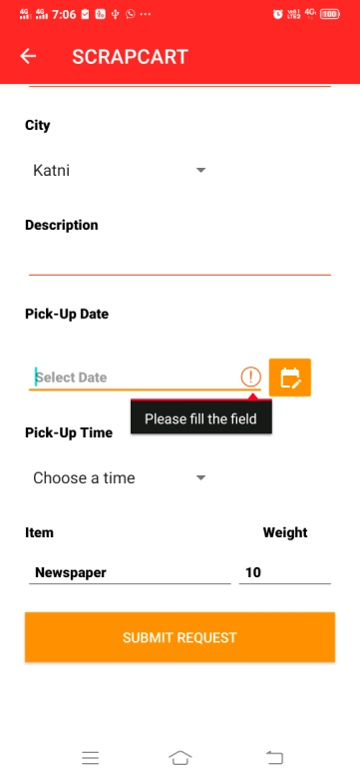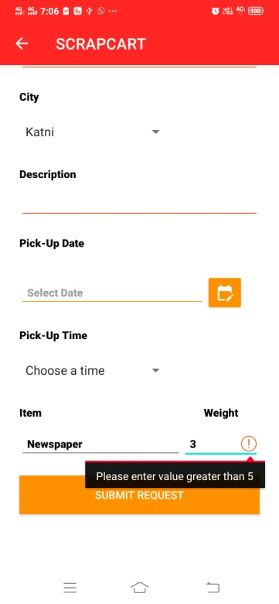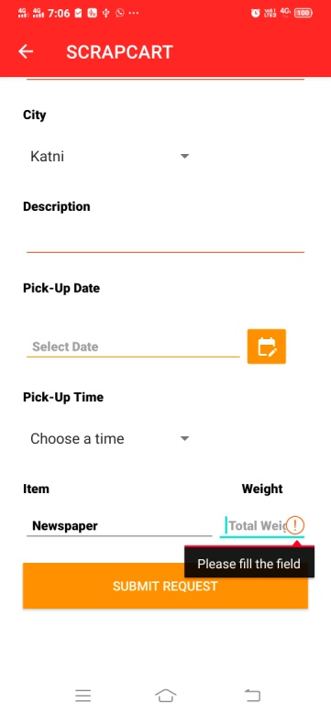

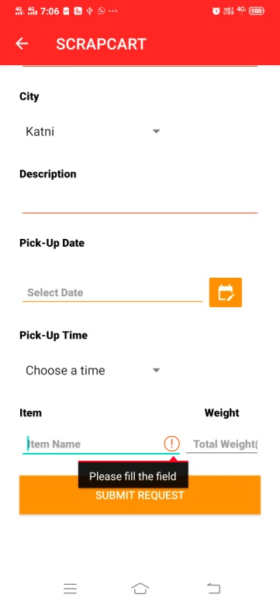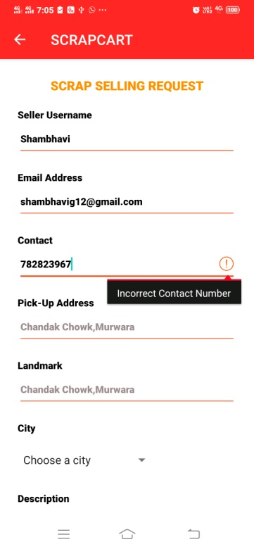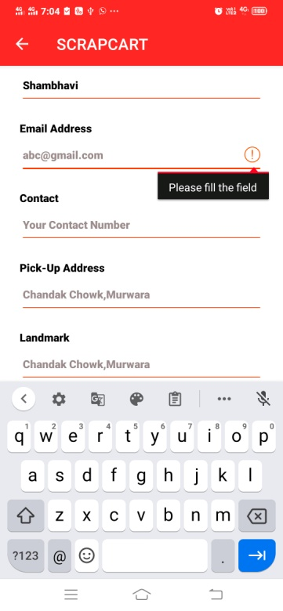

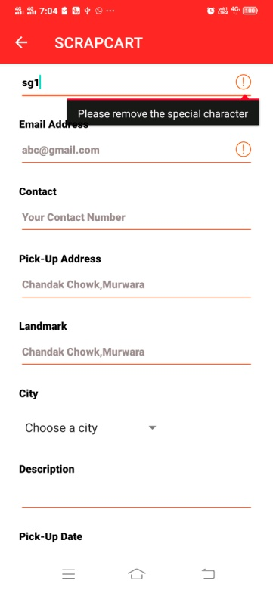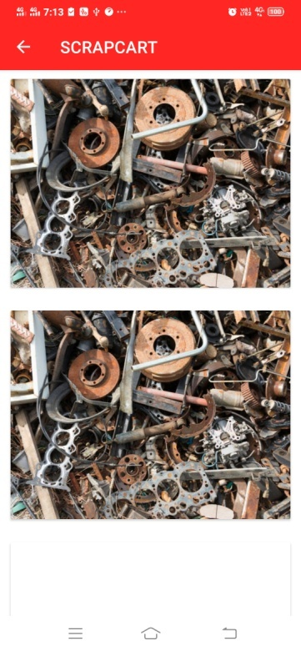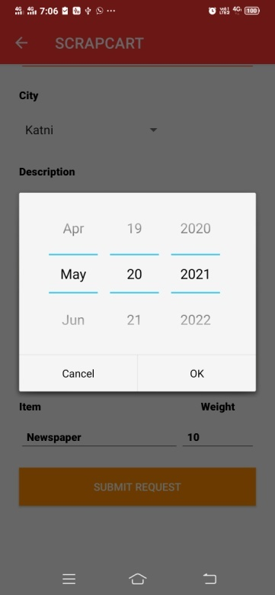

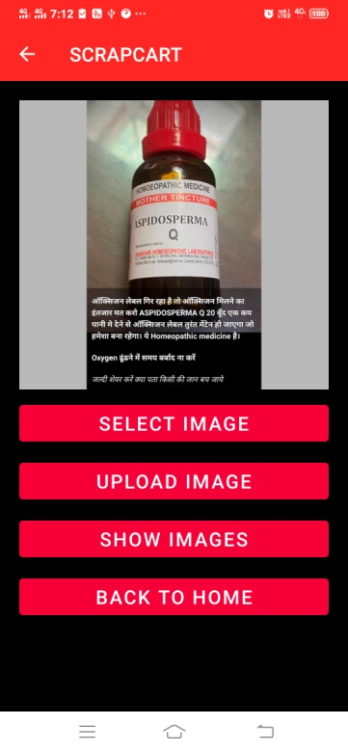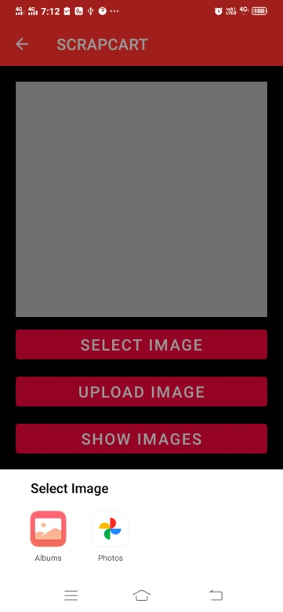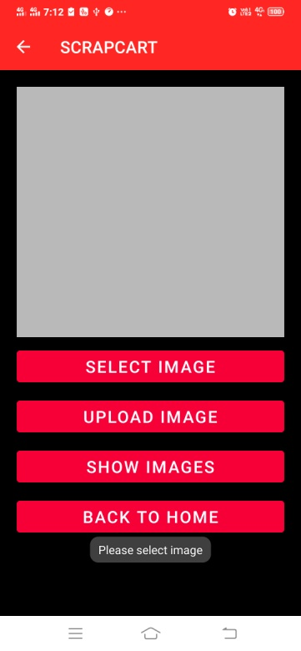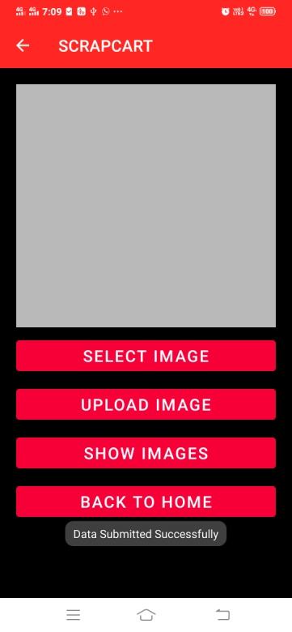

**Data Insertion Testing for New Buyers**

If new scrap buyers are inserted to the database table, the same details should be reflected back on the buyer’s page.

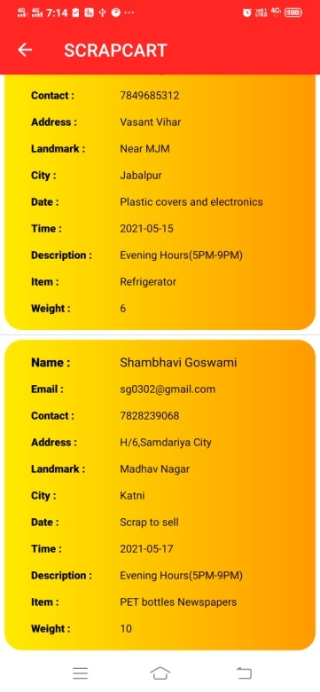



**Scheduling Request History**

This covers the segment of viewing all the requests that are being scheduled till the time for selling scrap.

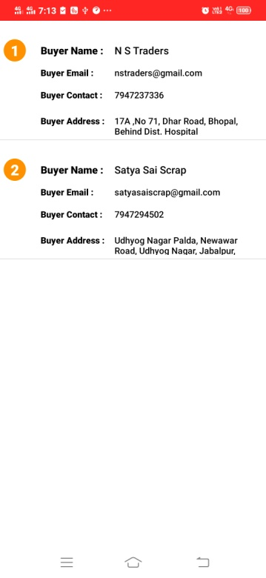

**State Transition testing (Overall activities)**

|  |  |  |
| --- | --- | --- |
| **S.no** | **Functional Requirements** | **Result** |
| 1 | Home to User journey activity | C:\Users\intel\AppData\Local\Microsoft\Windows\INetCache\IE\9ZC2ZNFT\Symbol-Correct-Mark-Ok-Choice-Right-Check-Yes-40319[1].png |
| 2 | Home to Scrap product retail list | C:\Users\intel\AppData\Local\Microsoft\Windows\INetCache\IE\9ZC2ZNFT\Symbol-Correct-Mark-Ok-Choice-Right-Check-Yes-40319[1].png |
| 3 | Home to Scrap scheduling request | C:\Users\intel\AppData\Local\Microsoft\Windows\INetCache\IE\9ZC2ZNFT\Symbol-Correct-Mark-Ok-Choice-Right-Check-Yes-40319[1].png |
| 4 | Home to Scheduling Request History | C:\Users\intel\AppData\Local\Microsoft\Windows\INetCache\IE\9ZC2ZNFT\Symbol-Correct-Mark-Ok-Choice-Right-Check-Yes-40319[1].png |
| 5 | Navigation view to Our Buyers activity. | C:\Users\intel\AppData\Local\Microsoft\Windows\INetCache\IE\9ZC2ZNFT\Symbol-Correct-Mark-Ok-Choice-Right-Check-Yes-40319[1].png |
| 6 | Back button to Home page | C:\Users\intel\AppData\Local\Microsoft\Windows\INetCache\IE\9ZC2ZNFT\Exclamation-Mark-Symbol-PNG[1].png |
| 7 | Back button to Navigation view | C:\Users\intel\AppData\Local\Microsoft\Windows\INetCache\IE\9ZC2ZNFT\Symbol-Correct-Mark-Ok-Choice-Right-Check-Yes-40319[1].png |
| 8 | On Logging out , prompts up to Log In page | C:\Users\intel\AppData\Local\Microsoft\Windows\INetCache\IE\9ZC2ZNFT\Symbol-Correct-Mark-Ok-Choice-Right-Check-Yes-40319[1].png |

**Deploying the application**

The application is being deployed on an android mobile by enabling the developer options in the system management settings. The USB debugging is then enabled for connecting the android studio platform with the mobile device and allowing the RSA key fingerprint popup.

Model number – vivo 1920

Android version – 10

**Bugs Identification**

|  |  |
| --- | --- |
| **S.no** | **Bugs** |
| 1 | Mobile view of User app journey(shifted from its original position) |
| 2 | On clicking Back button, it sets up the cursor to the navigation view instead of Home Activity. |

**Chapter 7**

**Result and Conclusion**

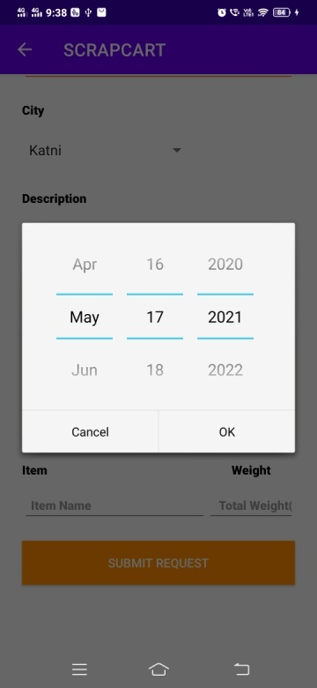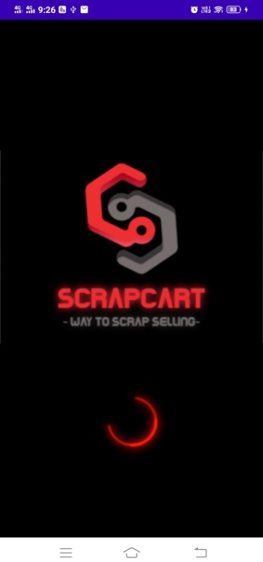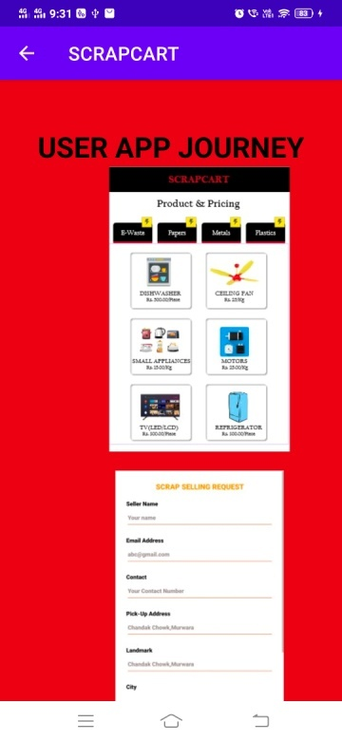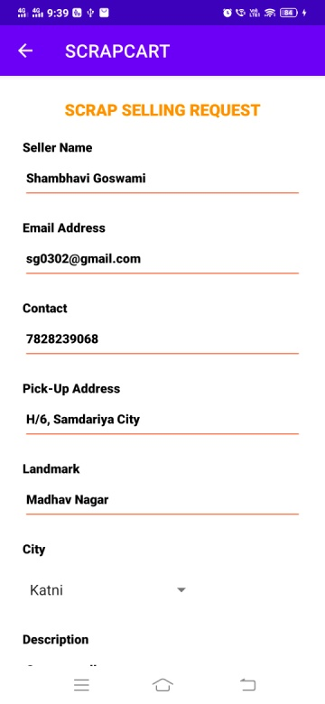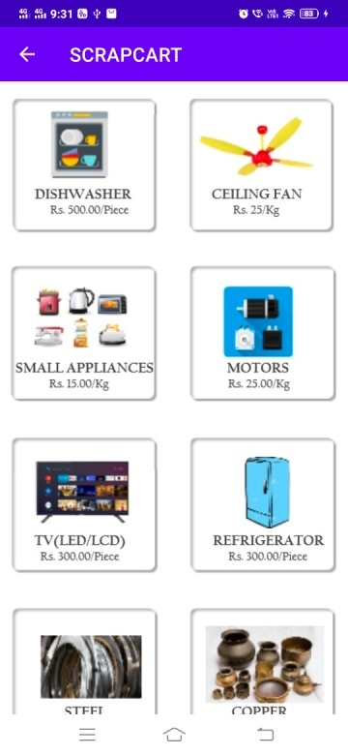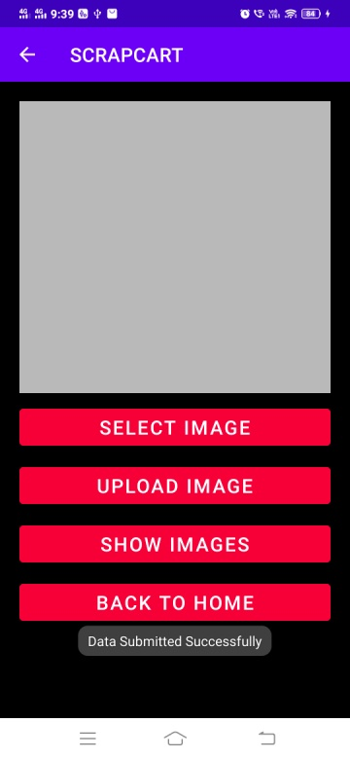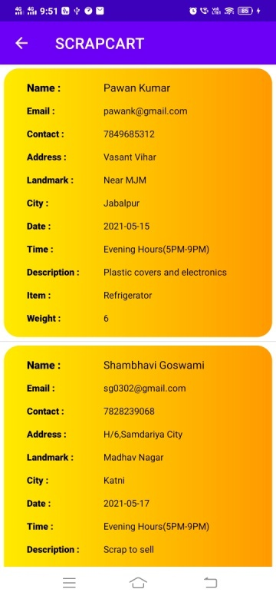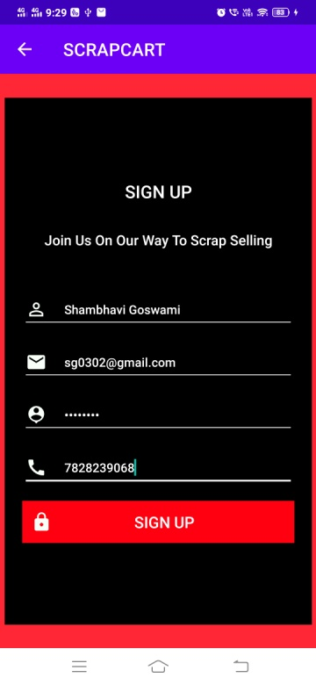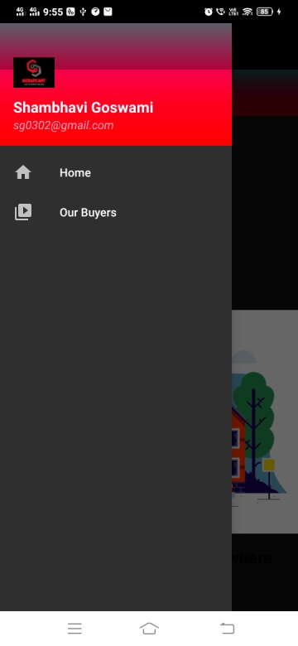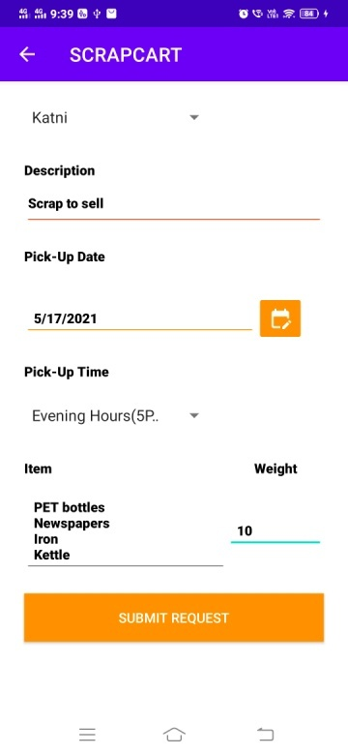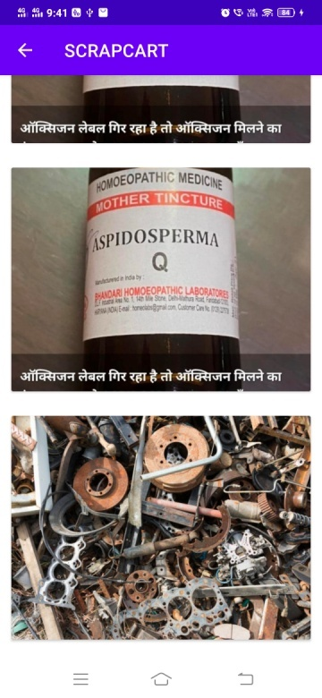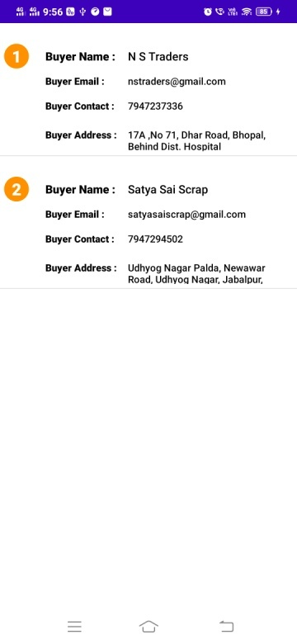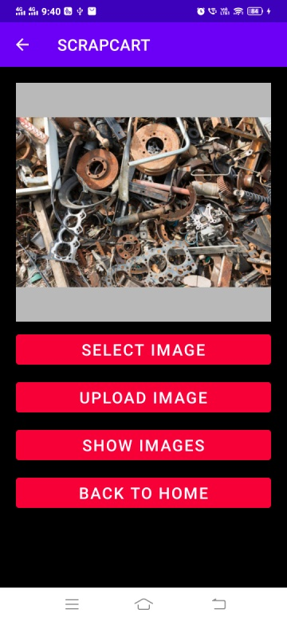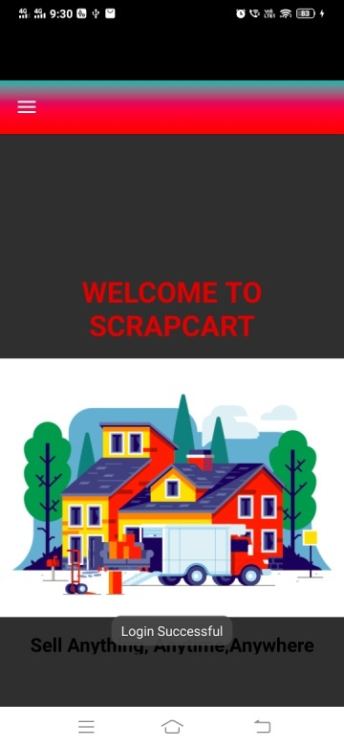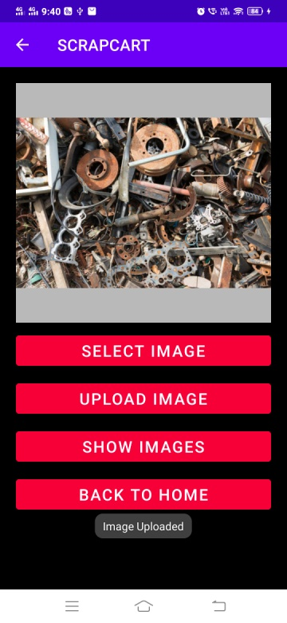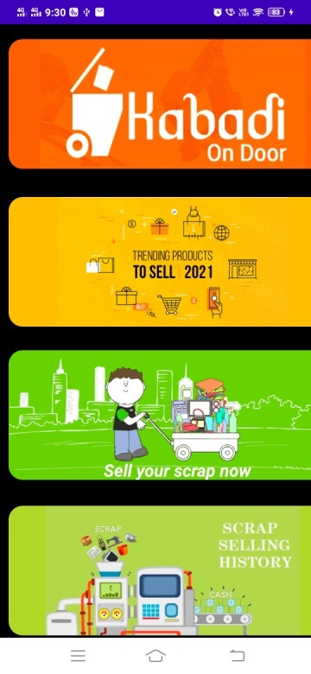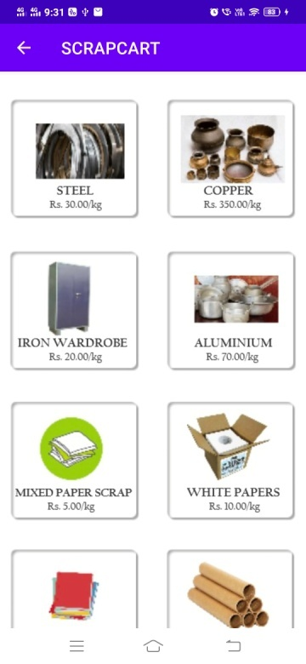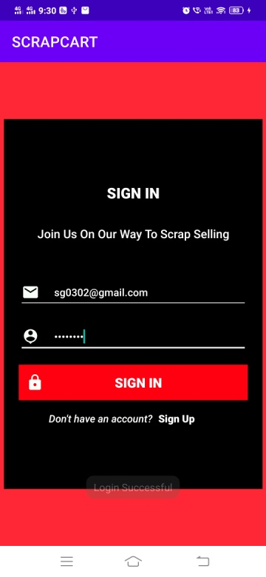

**Conclusion**

The testing of the application Scrapcart with different techniques like Error guessing and state transition technique and all the activities are being evaluated and results are being shown in the corresponding tables (with some bugs like adapting to the mobile view , the overall view gets changed from its original setup.)

**Chapter 8**

**References**

<https://www.imperva.com/learn/application-security/black-box-testing/>

<http://apktutor.com/gridview-with-image-and-text/>

<https://www.justdial.com/Indore/Satya-Sai-Scrap-Near-Choti-Lakhani-Udhyog-Nagar/0731PX731-X731-190911192055-S5C3_BZDET?xid=SW5kb3JlIFBsYXN0aWMgU2NyYXAgQnV5ZXJzIFNhbndlciBSb2Fk>

<https://www.tutorialspoint.com/android/android_php_mysql.htm>